JAVA PROGRAMMING

LABORATORY

09-26-2020.

Write a java program that implements the concept of interface. The program should include the following key features

Submitted By,

Tamilvanan B.

2018503566.

MO Batch.

1. An interface named customerTransaction which has a variable and public methods called costCalculation, customerRating and product details.

2. Create classes named goodCustomer, moderateCustomer and neglectedCustomer that implements the interface method, the program should display the customer transaction details and the product purchase details. The program should fix discount for each customer based on the rating. Define the method accordingly to implement this scenario.

Program

import java.util.Scanner;

interface customerTransaction{

int arr[] = new int[100];

int id = 0;

int n1 = 0;

int cost = 0;

double a = 0.0;

String pro[] = new String[100];

void costCalculation(int arr[]);

void details(int id, String pro[], int arr[], int n1, int cost);

double rating();

void transactionDetails(int arr[], double a);

}

class goodCustomer implements customerTransaction{

public int cost = 0;

public void costCalculation(int amount[]){

for(int i = 0; i < amount.length; i++){

cost += amount[i];

}

}

public void details(int id, String pro[], int amount[], int n1, int cost){

System.out.println("Id: " + String.valueOf(id));

for(int i = 0; i < n1; i++){

System.out.println("Name: " + pro[i]);

System.out.println("Amount: " + String.valueOf(amount[i]));

System.out.println("\n");

}

}

public double rating(){

return 0.25;

}

public void transactionDetails(int amount[],double a){

int cost = 0;

for(int i = 0; i < amount.length; i++){

cost += amount[i];

}

System.out.println("Actual amount to be paid is Rs." + String.valueOf(cost));

System.out.println("You\'re offered with a 25% Discount. So that you can pay Rs." + String.valueOf(cost - cost \* a));

}

}

class moderateCustomer implements customerTransaction{

int cost = 0;

public void costCalculation(int amount[]){

for(int i = 0; i < amount.length; i++){

cost += amount[i];

}

}

public void details(int id, String pro[], int amount[], int n1, int cost){

System.out.println("Id: " + String.valueOf(id));

for(int i = 0; i < n1; i++){

System.out.println("Name: " + pro[i]);

System.out.println("Amount: " + String.valueOf(amount[i]));

System.out.println("\n");

}

}

public double rating(){

return 0.10;

}

public void transactionDetails(int amount[], double a){

int cost = 0;

for(int i = 0; i < amount.length; i++){

cost += amount[i];

}

System.out.println("Actual amount to be paid is Rs." + String.valueOf(cost));

System.out.println("You\'re offered with a 10% Discount. So that you can pay Rs." + String.valueOf(cost - cost \* a));

}

}

class neglectedCustomer implements customerTransaction{

int cost = 0;

public void costCalculation(int amount[]){

for(int i = 0; i < amount.length; i++){

cost += amount[i];

}

}

public void details(int id, String pro[], int amount[], int n1, int cost){

System.out.println("Id: " + String.valueOf(id));

for(int i = 0; i < n1; i++){

System.out.println("Name: " + pro[i]);

System.out.println("Amount: " + String.valueOf(amount[i]));

System.out.println("\n");

}

for(int i = 0; i < amount.length; i++){

cost += amount[i];

}

}

public double rating(){

return 1.00;

}

public void transactionDetails(int amount[], double a){

int cost = 0;

for(int i = 0; i < amount.length; i++){

cost += amount[i];

}

System.out.println("Amount to be paid is Rs." + String.valueOf(cost \* a));

}

}

public class Customer{

public static void main(String... args){

Scanner sc = new Scanner(System.in);

Customer obj = new Customer();

while(true){

System.out.print("1. Run\n2. Exit\nEnter your choice: ");

int n = sc.nextInt();

if(n == 1){

System.out.print("Enter customerId: ");

int id = sc.nextInt();

System.out.print("Enter number of products purchased: ");

int n1 = sc.nextInt();

int arr[] = new int[n1];

String det[] = new String[n1];

for(int j = 0; j < n1; j++){

System.out.print(String.valueOf(j + 1) + "\n");

System.out.print("Name of the product: ");

det[j] = sc.next();

System.out.print("Price: ");

arr[j] = sc.nextInt();

}

int cost = 0;

for(int k = 0; k < n1; k++){

cost += arr[k];

}

if(cost >= 0 && cost <= 80){

neglectedCustomer obj1 = new neglectedCustomer();

obj1.costCalculation(arr);

System.out.println("\n\nProduct Details");

obj1.details(id, det, arr, n1, cost);

System.out.println("Tracnsaction Details");

double a = obj1.rating();

obj1.transactionDetails(arr, a);

}

else if(cost >= 80 && cost <= 150){

moderateCustomer obj1 = new moderateCustomer();

obj1.costCalculation(arr);

System.out.println("\n\nProduct Details");

obj1.details(id, det, arr, n1, cost);

System.out.println("Tracnsaction Details");

double a = obj1.rating();

obj1.transactionDetails(arr, a);

}

else if(cost > 150){

goodCustomer obj1 = new goodCustomer();

obj1.costCalculation(arr);

System.out.println("\n\nProduct Details");

obj1.details(id, det, arr, n1, cost);

System.out.println("Tracnsaction Details");

double a = obj1.rating();

obj1.transactionDetails(arr, a);

}

else{

System.out.print("Cannot be displayed\n");

}

}

else if(n == 2){

break;

}

}

}

}

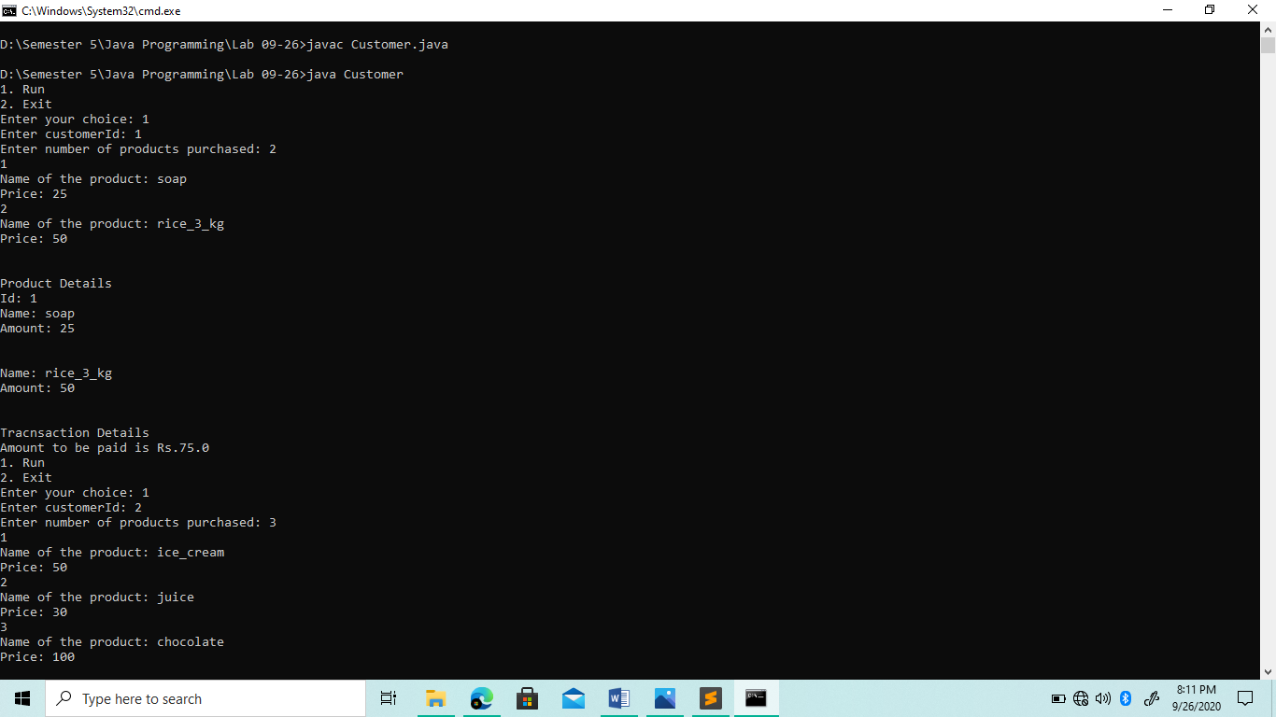Output

